Want to know more? Follow me or connect🥂



 𝗔𝗣𝗜 𝗚𝗮𝘁𝗲𝘄𝗮𝘆 𝗣𝗮𝘁𝘁𝗲𝗿𝗻: Use a single entry point to manage requests to microservice world.  
  
📮 𝗕𝗮𝗰𝗸𝗲𝗻𝗱𝘀 𝗳𝗼𝗿 𝗙𝗿𝗼𝗻𝘁𝗲𝗻𝗱𝘀 (𝗕𝗙𝗙): Tailor backend services for each specific user interface.  
  
🍂 𝗔𝗴𝗴𝗿𝗲𝗴𝗮𝘁𝗼𝗿 𝗣𝗮𝘁𝘁𝗲𝗿𝗻: Allows to abstract the business logic from multiple services and aggregate them in a single microservice  
  
🔰 𝗦𝘁𝗿𝗮𝗻𝗴𝗹𝗲𝗿 𝗣𝗮𝘁𝘁𝗲𝗿𝗻: Gradually transition from monolith to microservices.  
  
❄️ 𝗦𝗲𝗿𝘃𝗶𝗰𝗲 𝗗𝗶𝘀𝗰𝗼𝘃𝗲𝗿𝘆 𝗣𝗮𝘁𝘁𝗲𝗿𝗻: Automatically detects and connects services.  
  
🚪 𝗖𝗶𝗿𝗰𝘂𝗶𝘁 𝗕𝗿𝗲𝗮𝗸𝗲𝗿 𝗣𝗮𝘁𝘁𝗲𝗿𝗻: Prevents cascading failures ensure quick recovery.  
  
🎧 𝗕𝘂𝗹𝗸𝗵𝗲𝗮𝗱 𝗣𝗮𝘁𝘁𝗲𝗿𝗻: Isolate parts of the system to prevent failures from cascading.  
  
💱 𝗥𝗲𝘁𝗿𝘆 𝗣𝗮𝘁𝘁𝗲𝗿𝗻: Automatically retry operations that have previously failed.  
  
🚘 𝗦𝗶𝗱𝗲𝗰𝗮𝗿 𝗣𝗮𝘁𝘁𝗲𝗿𝗻: Attach helper services to enhance main service functionalities.  
  
📦 𝗗𝗮𝘁𝗮𝗯𝗮𝘀𝗲 𝗽𝗲𝗿 𝗦𝗲𝗿𝘃𝗶𝗰𝗲: Each microservice have own database ensures loose coupling and independence between services  
  
🔗 𝗦𝗮𝗴𝗮 𝗣𝗮𝘁𝘁𝗲𝗿𝗻: Ensure data consistency across distributed services.  
  
🎭 𝗖𝗼𝗺𝗺𝗮𝗻𝗱 𝗤𝘂𝗲𝗿𝘆 𝗥𝗲𝘀𝗽𝗼𝗻𝘀𝗶𝗯𝗶𝗹𝗶𝘁𝘆 𝗦𝗲𝗴𝗿𝗲𝗴𝗮𝘁𝗶𝗼𝗻 (𝗖𝗤𝗥𝗦): Separates the write and read operations, optimizing for performance and scalability.  
  
⚙️ 𝗖𝗼𝗺𝗽𝗼𝘀𝗶𝘁𝗲 𝗠𝗶𝗰𝗿𝗼𝘀𝗲𝗿𝘃𝗶𝗰𝗲𝘀 𝗣𝗮𝘁𝘁𝗲𝗿𝗻: Aggregate results from multiple services.  
  
🗒 𝗖𝗼𝗻𝗳𝗶𝗴𝘂𝗿𝗮𝘁𝗶𝗼𝗻 𝗘𝘅𝘁𝗲𝗿𝗻𝗮𝗹𝗶𝘇𝗮𝘁𝗶𝗼𝗻 𝗣𝗮𝘁𝘁𝗲𝗿𝗻: Keep configuration settings outside of the application code.  
  
📨 𝗘𝘃𝗲𝗻𝘁 𝗦𝗼𝘂𝗿𝗰𝗶𝗻𝗴 𝗣𝗮𝘁𝘁𝗲𝗿𝗻: Capture state changes as a series of events for reliable auditing.  
  
🎎 𝗢𝗯𝘀𝗲𝗿𝘃𝗲𝗿 𝗣𝗮𝘁𝘁𝗲𝗿𝗻: Allow services to subscribe to and react to events.  
  
🎐 𝗛𝗲𝗮𝗹𝘁𝗵 𝗖𝗵𝗲𝗰𝗸 𝗔𝗣𝗜 𝗣𝗮𝘁𝘁𝗲𝗿𝗻: Regularly check the health of services to ensure reliability.  
  
📇𝗗𝗶𝘀𝘁𝗿𝗶𝗯𝘂𝘁𝗲𝗱 𝗧𝗿𝗮𝗰𝗶𝗻𝗴: Tracks requests as they traverse through multiple microservices enables efficient troubleshooting.  
  
📈 𝗣𝗲𝗿𝗳𝗼𝗿𝗺𝗮𝗻𝗰𝗲 𝗠𝗲𝘁𝗿𝗶𝗰𝘀: Metrics collection such as response time, error rate, throughput, and resource utilization provide insights into the system’s health and performance.  
  
🌗𝗕𝗹𝘂𝗲-𝗚𝗿𝗲𝗲𝗻 𝗗𝗲𝗽𝗹𝗼𝘆𝗺𝗲𝗻𝘁: Blue-green deployment enables seamless updates with minimal downtime and provides a rollback option if issues arise

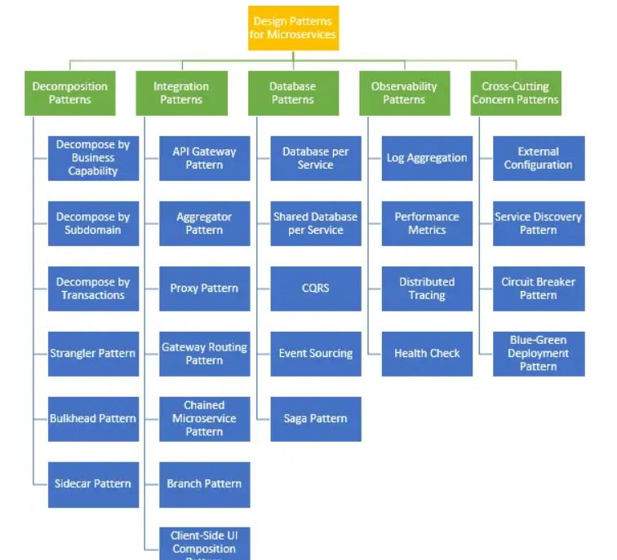



𝐏𝐫𝐢𝐧𝐜𝐢𝐩𝐥𝐞𝐬 𝐨𝐟 𝐀𝐏𝐈 𝐝𝐞𝐬𝐢𝐠𝐧  
  
Creating an effective API involves more than just writing code; it requires thoughtful design to ensure usability, scalability, and security. Let's explore essential principles to guide you in developing your next API.  
  
  
𝐒𝐞𝐜𝐮𝐫𝐢𝐭𝐲  
- Authentication and Authorization: Implement robust security measures to protect data and prevent unauthorized access.  
  
𝐃𝐨𝐜𝐮𝐦𝐞𝐧𝐭𝐚𝐭𝐢𝐨𝐧  
- Comprehensive Guides: Provide detailed documentation, including usage examples, to help developers understand and use your API effectively.  
  
𝐕𝐞𝐫𝐬𝐢𝐨𝐧𝐢𝐧𝐠  
- Manage Changes: Use versioning to handle changes without disrupting existing users.  
- Backward Compatibility: Strive to maintain backward compatibility when introducing new features or updates.  
  
 𝐏𝐞𝐫𝐟𝐨𝐫𝐦𝐚𝐧𝐜𝐞  
- Optimize Speed: Ensure your API responds quickly and efficiently, minimizing latency.  
  
 𝐄𝐫𝐫𝐨𝐫 𝐇𝐚𝐧𝐝𝐥𝐢𝐧𝐠  
- Clear Messages: Provide clear and informative error messages to help developers diagnose and fix issues.  
- Standard Codes: Use standard HTTP status codes to communicate the status of API requests.  
  
𝐅𝐥𝐞𝐱𝐢𝐛𝐢𝐥𝐢𝐭𝐲  
- Adaptability: Design your API to be flexible and adaptable to changing requirements and technologies.  
  
 𝐔𝐬𝐚𝐛𝐢𝐥𝐢𝐭𝐲  
- Developer Experience: Focus on the developer experience, making it easy to integrate and use your API.  
- Feedback Loop: Encourage and incorporate feedback from users to continually improve the API.  
  
 𝐓𝐞𝐬𝐭𝐢𝐧𝐠  
- Automated Testing: Implement automated tests to ensure API functionality and reliability.  
- End-to-End Testing: Conduct end-to-end tests to validate that the API works as expected in real-world scenarios.  
  
 𝐃𝐢𝐬𝐜𝐨𝐯𝐞𝐫𝐚𝐛𝐢𝐥𝐢𝐭𝐲  
- API Gateway: Use an API gateway to manage and monitor traffic, improving discoverability and management.  
- API Catalog: Maintain a catalog of available APIs  
  
𝐑𝐚𝐭𝐞 𝐋𝐢𝐦𝐢𝐭𝐢𝐧𝐠  
- Control Usage: Implement rate limiting to control the number of requests a client can make  
- Prevent Overload: Use rate limiting to prevent server overload and maintain performance.  
  
 𝐂𝐚𝐜𝐡𝐢𝐧𝐠  
- Improve Efficiency: Use caching mechanisms to reduce server load and improve response times.  
- Data Freshness: Balance caching with the need for up-to-date information  
  
 𝐈𝐧𝐭𝐞𝐫𝐧𝐚𝐭𝐢𝐨𝐧𝐚𝐥𝐢𝐳𝐚𝐭𝐢𝐨𝐧  
- Global Reach: Design your API to support multiple languages and regions, making it accessible to a global audience.  
- Localization: Allow for localization of responses based on the user's locale and preferences.

